MARCH 2017

St. Cloud Heritage Quilters
www.stcloudheritagequiltersofmn.com

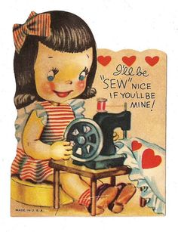
I hope you all are staying warm and getting a lot of sewing done. I’m trying to keep a New Year resolution to teach my grandkids to sew. This hasn’t been easy with their busy schedules, but I did have Annie and Sydney design and help sew small baby quilts for charity last weekend. I also bought my very first kit from a quilt store, and put the entire top together. It was an interesting challenge for me, because the picture and directions did not show or tell which way to place the seams to sew together the rows. At least it is ready to be quilted.
I was very happy that our speaker, Cindy Staub, from Quilt Doodle Designs, brought so many patterns to our meeting last month that were perfect for smaller projects. Next month we have a delightful speaker, Sara Hardwig, from Blueberry Backroads, coming to give us a talk and trunk show. Bring a friend. It’s sure to be a fun evening. We also have a great opportunity to take a day-long class at Love of Christ Church, from Denyse Schmidt, on Friday March 31. She is an acclaimed modern designer, quilter, and author. The cost of this Improvisational class is $125 and will be a great chance to use up a lot of smaller pieces of material you have. See Special Events Coordinator, Karen Cyson, to sign up.
I hope to see you all at the March 2nd meeting.
Contact Terri Bahn terri.bahn@gmail.com

PRESIDENT’S COLUMN Terri Bahn
Next Meeting: March. 2, 2017
Love of Christ Lutheran Church 1971 Pine Cone Road S.
St. Cloud, MN 56303
Click here for directions
7:00 P.M

Happy Valentine’s Day to You!

See the Quilt Guild calendar on page 8.
President
Terri Bahn
terri.bahn@gmail.com

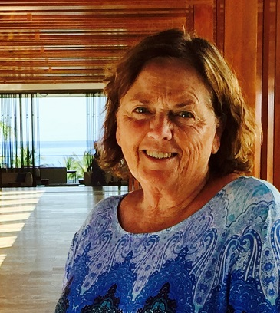
Please continue to work on the cancer bags and bring any completed bags to our March meeting.
If you have any pieced tops for Quilts of Valor, bring those along and we will pass them to the quilters. Also, we will have several kits at the March meeting, so if you are interested in piecing a top, let me know.
Contact Jean Euteneuer eutenkev@gmail.com

There are still a few openings in the March 31 Denyse Schmidt Improv Piecing Workshop. If you are interested in registering, please contact me by email or phone. (Karen’s phone number can be found on the mailing page attached with this newsletter.)
Members who are interested in making baskets (like the ones we made earlier) may have an opportunity to join the Mississippi River Spinners Guild workshop on May 20. Contact me by phone or email if you are interested.
Contact Karen Cyson karencyson@aol.com

SPECIAL EVENTS Karen Cyson

SERVICE PROJECTS Jean Euteneuer

Our speaker for the March 2nd meeting is Sara Hardwig of Blueberry Backroads. At Blueberry Backroads, they’re all about embroidery and Sara is the designer. They specialize in stitchery patterns for every season with whimsical designs and an eye toward nature – from springtime flowers to winter’s falling snowflakes. Their projects are small and easy to take with you, and they offer complete pattern instructions full of tips. Love wool appliqué? They have a little bit of that too! Check out their website at http://blueberrybackroads.com/
Sara also has a blog http://blueberrybackroads.com/blogs/blueberry-backroads with lots of tutorials and tips.
Contact Sandy Anderson northwoodsandy@gmail.com

PROGRAMS Sandy Anderson

The September 6, 2012 meeting of the Board of SCHQ was called to order at 5:41 p.m. by chair Maggie Voigt.
Present were board members Maggie Voigt, Gwen Carlson, Reither, Marjorie LaTour, Karen Berkman, Karen Cyson, Jane Mastroianna, Elvis Grau, Elaine Randall, Audrey Abraham, Brook Strassburg, Charlene Fleischhacker, and Show Chair Kathy Crabtree.
Chair: As per our bylaws we will be holding election of officers at the October general meeting. We are continuing to look for new officers. No one may hold the same office for more than 2 consecutive years. MV has forms for securing our rental space at Bethlehem for 2013. The only meeting that will not be the first Thursday is the July meeting due to the Independence Day holiday.
Motion MV, second MLT to approve the minutes of the August meeting. Motion passed.
Treasurer: The August treasurer's report was presented. Motion MLT, second MV to move $2000 from savings to checking to cover bills that will be due before membership dues monies are received. Motion passed. No sales tax is currently owed by our guild. Magazine subscription order will be resubmitted.
Secretary: Information on discounts for Taunton Press magazines, JoAnn Fabrics, Michaels, & Just Sew Studios will be announced at the general meeting and published in the newsletter.
Program: The October meeting is our guild Birthday Party. Those with last names K-L will be asked to bring cookies. BS will check on use of kitchen and coffee makers.
Newsletter: Less expensive paper was purchased for print copies of the newsletter, We cannot use lighter weight paper as it will get scrunched in the mailing process.
Membership: One new member last month. Membership is now at 140
Special Events: No report
Small Group: No report
Service projects: At the general meeting people will be thanked for their contributions. We are still working on quilts for Quiet Oaks. They need lap and double-bed size quilts.
Sunshine: One card sent this month.
Librarian: No report
Webmaster: No report
Historian: Please stand by your quilt during Show'n'Tell so you will appear in the photo with your project.
Quilt Show: First meeting was held and pattern for raffle quilt and a theme for the show were discussed. Show still needs a publicity chair.

Old Business:
Facility: The only date change for next year's contract with Bethlehem Lutheran Church will be the July meeting date. We will add one table to the contract for each month and more on a monthly basis as needed for our meeting. Motion JM, second BS to approve the contract at $181 per month (includes extra table) for facility rental. Motion passed.
Membership Dues: Current membership dues are $25 with electronic newsletter subscription, $30 with mailed paper newsletter. It costs $9.60 per year to print and mail the newsletter which includes ink, paper, seals, and postage. Seventeen members have their newsletter mailed. Motion KC, second ER to change dues structure to $25 with electronic newsletter delivery, $30 with paper copy picked up at meeting, $35 with paper copy mailed to member. Motion passed. Membership renewal forms will be in the October newsletter.
All other Old Business and New Business were tabled until October meeting due to time constraints.
MV adjourned meeting at 6:40 p.m.
Respectfully submitted,
Karen Cyson, Secretary

We have a variety of small groups that meet during the month. We would like you to facilitate or start a new group. Let Peggy know if you need help or want to share ideas. Then consider joining one or more of these small groups. Sign-up sheets are available at every meeting. For the list of groups check out our website: http://www.stcloudheritagequiltersofmn.com/
Busy Hands, Happy Hearts - This group meets the last Tuesday of the month, 1:00pm-9:30 pm., or anytime in between, to accommodate people who do not wish to go out at night, at Peggy’s house, in north St. Cloud. The group is for anyone who wants to do any type of handwork, English piecing, embroidery, beading, knitting, crocheting, coloring books, hand piecing of their own - anything not requiring electricity, except for a lamp. Contact peggyssewingbox@hotmail.com to be added to the email list for meeting notices.
Featherweight Group - This group does fun projects throughout the year. To be part of this group, you must own and bring a Featherweight sewing machine. Bev Radaich is the facilitator. They meet the second Thursday of the month at 9:30 am at Messiah Lutheran Church in Sartell, MN. Contact Bev to be added to the email list for meeting notices. (Bev’s email address can be found in the guild membership directory.)
Wooly Bright Group - This new group will meet the third Wednesday of the month, at the St. Cloud Public Library in the Array room on first floor, at 7 pm. Sarah Howard is the facilitator. Bring whatever wool project you are working on and ideas. There will be plenty of time to work on or begin a wool project of your choice. Contact Sarah Howard to be added to the group emails. (Sarah’s email address can be found in the guild membership directory.)
The “New Hexagon Book” Club + any type of English Piecing Group – This group will continue where the English Piecing group left off at Dunn Brothers last year’s class. We can work on any pattern or type of English piecing, hexie, or other shapes.
If we want to begin the latest craze of millefiore piecing, that is the part we call, “The New Hexagon Book” Club. Those who want to work on patterns from the New Hexagon Book, need to own the book before we can do the patterns.
This group will meet the first Tuesday of the month at Peggy’s house, in St. Cloud, 4:30—9:30, or anytime in between. English piecing is all hand work and for all levels. Eat before you come, bring your own supper, or bring something for potluck to share. No pressures, no worries, no competitions, no judgments….just come to have fun and be inspired. Contact peggyssewingbox@hotmail.com to be added to the email list for meeting notices.
Undercolor Club – This group meets the 4th Wednesday of the month at 5:30 pm at Dunn Bros. Coffee Shop in the Coborn's on Cooper Ave. S. The next meeting will be on Feb. 22, at 5:30 pm. Our challenge for this meeting is found on page 68 in Joen Wolfrom's book "Color Play" 2nd Edition. Spring Green in an Analogous Plan is the challenge topic. Make a block, small project or bring those colors of fabrics or pictures from magazines or books. Contact Marlyn Anderson pyromarquilter@gmail.com.
(Continued on page 4)
SMALL GROUPS Peggy Aschenbrenner

SMALL GROUPS (Continued) Peggy Aschenbrenner

Charm Group - Anyone interested in starting or joining a “Charm Group”? It would be a group where we would trade 5” squares and/or work with charm packs. We would make any project of your choice using a 5” square once somewhere in the project. You can use yardage for borders, sashing, etc.
All these groups are looking for new members. Won't you consider joining one or all these groups?
Contact Peggy for questions or suggestions for small groups.
Contact Peggy Aschenbrenner peggyssewingbox@hotmail.com

HELP NEEDED…
Anyone willing to accompany Marlyn Anderson to Duluth on June 5th to hang our Granite City Rocks quilts, please contact Marlyn at pyromarquilter@gmail.com or call her at the number listed in your guild membership directory.
This will only be a day trip up, hang quilts, and back home that day. Maybe some quilt shop stops along the way?
I also need someone to take down the quilts at the end of the show on Sat. June 10th. This would be after 4 pm. I have a previous commitment in St. Paul that day, so can't do it myself.
Thanks,
Marlyn Anderson

MEMBERSHIP Marlys Eikmeier

As of our last meeting we have 137 paid members! I still have lots of pink cards so remember to pick yours up!
With the wonderful spring-like weather we have been having, one has to wonder if we will have an early spring. As much as I love spring and look forward to it, I get more time in my quilting room during the winter. I don’t have all my winter projects done yet! Either way, we have no control, we get to enjoy every day and decide how we want to spend that day!
New members this month include: Vicki Butner and Marian Haus
Contact Marlys Eikmeier eikma@hotmail.com

2017 President’s Challenge
Using the Inspiration of Vintage Yard Long Prints
Your 12” x 36” finished quilt can be pictorial, traditional block, modern design, a table runner pattern, or landscape quilt. You can use any techniques on the quilt that you want to try. Although it would be easier to hang the narrow quilts vertically, if you have a horizontal landscape or picture, we will make sure it gets hung in the quilt show that way. The horizontal quilts should have a hanging sleeve sewn on the back. All quilts should have a label with your name on the back. They should have three layers and binding like a traditional quilt. Any questions call or email me. This is a fun way to show the diversity of our group!
Terri Bahn terri.bahn@gmail.com

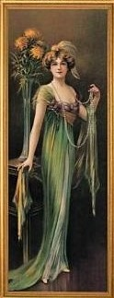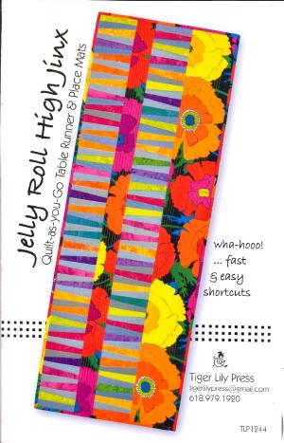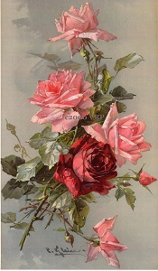

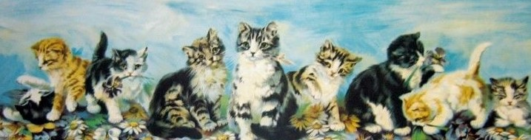

QUILT SHOW 2017 Cindy Kleve and Sandy Keller

“Fall In Love with Quilting”
We are sorry we missed the meeting last month. We would have loved to see the reaction when the two featured quilters for the 2017 show were announced. We are excited to have Marilyn Bujalksi and Marlyn Anderson as our featured quilters!!
Be sure to come to the March meeting. We will be displaying the finished raffle quilt for everyone to see. We hope you love it as much as we do.
Reminder to everyone to bring your raffle baskets - you can donate any items to put towards a basket or you can donate a whole basket.
The 2017 Quilt Show dates are Saturday October 14, 2017 - Sunday October 15, 2017.
Contact Cindy Kleve cindysmq@mail.com and Sandy Keller imagine761@hotmail.com

Anyone is welcome to put an article in the newsletter. The deadline for receipt of articles to appear in the April 2017 newsletter is March 12th. The guild also accepts ads. Contact me for advertising rates and requirements.
Articles and ads should be sent to me at marie.zaczkowski@gmail.com.

.

NEWSLETTER Marie Zaczkowski
Thank you to the holders and folders at the February meeting:

Terri Bahn
Bonita Benschoter
Ann Chmielewski
Jean Eutenener
Sue Roblik
Pam Schirmers

Your help is appreciated!

KUDOS TO. . .
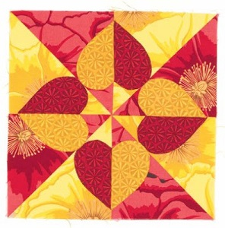
Amended January Report
Expenses
 | Garage Sale Payment | -$39.50
 | Programs - Speaker | -$167.20
 | Website | -$50.00
 | Treasurer | -$9.00
 | Membership Refund | -$25.00
 | TOTAL EXPENSES | -$290.70
Income
 | Birthday Fabric | $50.25
 | Membership Fees | $740.00
 | Refreshments | $24.10
 | TOTAL INCOME | $814.35
February Report
Beginning Balance 2/2/2017 |  | $6,963.96
Expenses
 | Programs - Speaker | -$247.50
 | Treasurer | -$9.80
 | TOTAL EXPENSES | -$257.30
Income
 | Birthday Fabric | $70.00
 | Membership Fees | $380.00
 | Refreshments | $14.17
 | TOTAL INCOME | $464.17
Contact Mary Proell xrayproell@hotmail.com

TREASURER’S REPORT Mary Proell
ST. CLOUD HERITAGE QUILT GUILD CALENDAR

Remember to bring your 2017 membership card and wear your name tag at the meetings. Bring your show and tell items, birthday fabric, $ for birthday fabric, and any library books that need to be returned.

March 2 -- Board Meeting, 6:00; Guild Meeting, 7:00; Sara Hardwig, Blueberry Backroads Embroidery http://blueberrybackroads.com/

April 6 -- Board Meeting, 6:00; Guild Meeting, 7:00 Ruth Anne Cheney, Quilting on the Curve http://www.quiltingonthecurve.com/about-me.html

May 4 -- Board Meeting, 6:00; Guild Meeting, 7:00 Taunja Kelvington, Carried Away Quilting http://carriedawayquilting.blogspot.com/

June 1 -- Board Meeting, 6:00; Guild Meeting, 7:00 Susan Stein, Textile Art Samplers http://www.susan-stein.com/

July 6 -- Board Meeting, 6:00; Guild Meeting, 7:00

Aug. 3 -- Board Meeting, 6:00; Guild Meeting, 7:00 Darlene Smith, One Wing Wool http://www.onewingwool.com/

Sept. 7 -- Board Meeting, 6:00; Guild Meeting, 7:00 Getting Ready for the Quilt Show

Oct. 5 -- Board Meeting, 6:00; Guild Meeting, 7:00 Julie Huseth, “Quilts and the Underground Railroad”
Guild Birthday Bash (White and Chocolate Cupcakes)

Nov. 2 -- Board Meeting, 6:00; Guild Meeting, 7:00 Amanda Jean Nyberg, Crazy Mom Quilts http://crazymomquilts.blogspot.com/

Dec. 7 -- Board Meeting, 6:00; Guild Meeting, 7:00 Holiday Tea (Potluck), Games and Prizes

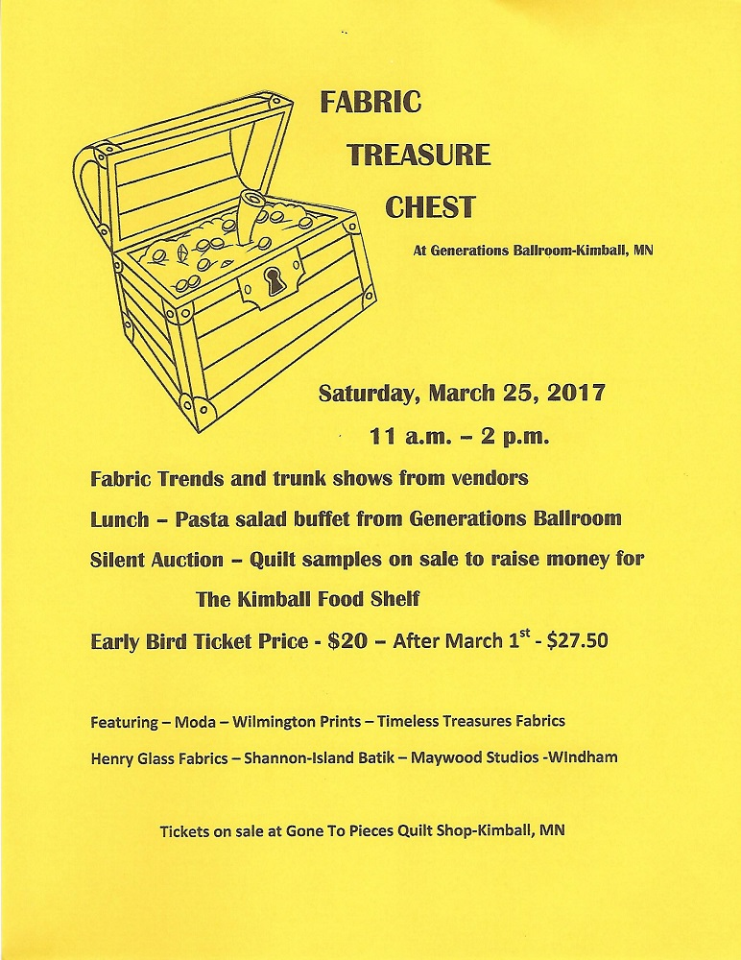

Fergus Falls Festival of Quilts
2017 – 8th Biennial Quilt Show & Conference
“Threaded Memories!”
March 23, 24, & 25, 2017
THURSDAY: 4 pm – 8 pm
FRIDAY: 9 am – 6 pm
SATURDAY: 9 am – 4 pm
Bigwood Event Center 925 Western Avenue, in Fergus Falls. Located just off of I-94 and Hwy. 210, Fergus Falls, MN
Presented by Fergus Falls Area Quilters
The Fergus Falls area quilt guilds present our 8th quilt show, Threaded Memories!, showcasing beautiful quilts, merchants, classes and lectures. We are excited this year to have Kathryn Squibb and Deborah Jacobs from Gathering Friends Quilt Shop as our main teachers. They will also be presenting Color Makes the Quilt! at the banquet Friday night.
Our bed turning luncheon will be back on Friday and Quilters Embrace will present their mission at the Saturday luncheon. A good variety of classes are being offered as well as free mini-seminars offered at various times during the show. We have something for everyone – techniques, special rulers, applique, wool, how to plan a quilt, and, of course, shopping!

So, enter your quilts, sign up for the classes and luncheons, and come and be inspired, learn a new skill or two, buy raffle tickets for Passing Fancy, invite your friends, and enjoy meeting with your fellow quilters.

If you would like an electronic copy of the show information booklet, please email jacks2@charter.net or you can go to fergusquiltersblogspot.com to download the booklet and forms for registration and quilt entry.

