## 

November 2019

St. Cloud Heritage Quilters

[www.stcloudheritagequiltersofmn.com](http://www.stcloudheritagequiltersofmn.com)

**Next Meeting: Nov. 7th, 2019**

Love of Christ Lutheran Church 1971 Pine Cone Road S.

St. Cloud, MN 56303

[Click here](https://www.google.com/maps/place/1971+Pine+Cone+Rd+S,+St+Cloud,+MN+56303/@45.5853668,-94.2232814,678m/data=!3m1!1e3!4m2!3m1!1s0x52b45e9135499525:0x62d24bbada5743a8?hl=en) for directions

7:00 P.M

# PRESIDENT’S COLUMN Sandy Anderson

`

A big “thank you” goes out to the Quilt Show Committee for their hard work making our show great. Many great comments were heard.

The “garage sale” at the October meeting was also a hit. The police officer speaking on cyber security was very informative. I heard, “that was the best meeting we have had in a long time”.

We will be voting on new members for the 2020 board at the November meeting. The following members have been nominated to fill board positions.

President/Co-president: Chris Hoover & Julie Johnson

Secretary: Barb Corson & Paulette Bober-Lind

Treasurer/Co-Treasurer: Diane Kremer & Maggie Voigt

Service Projects: Pat Gerchy & Sue Skoblik

Membership: Julie Anderson & Fawn Wright

Program Chairs: Nancy Piltz, Terri Olson, Darlene Felling & Teri Durbin

Small Groups: Diann Kremer & Jan Stockinger

Undercolor Club – Marlyn Anderson

Wooly Brights – Marjorie La Tour

Featherweight – Julie Johnson & Jean Gilbertson

Special Events – Alice Sue Becker & Sandy Anderson

The following members have volunteered to fill appointed positions:

Birthday/ Membership Prizes: Kathy Gunderson & Peggy Krull-Bordewick

Sunshine: Mona Ritter

(Continued on page 2)

**President**

**Sandy Anderson**

[**northwoodsandy@gmail.com**](mailto:northwoodsandy@gmail.com)

**See the Quilt Guild calendar on page 6.**

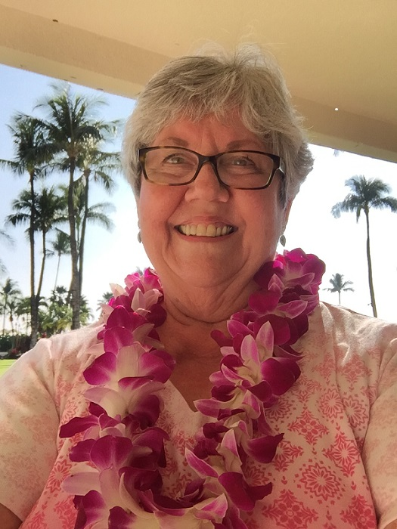

**PROGRAMS Teri Durbin**

The speaker for our November meeting is **Angie Roberts** with **Noble Quilter Shop** in Elk River. Angie is the owner of The Noble Quilter, a shop that carries over 3500 bolts of fabric as well as notions, books and patterns. For this program, Angie will be sharing with us information on incorporating embroidery into your quilts.

**Contact Teri Durbin:**

**SPECIAL EVENTS Alice Sue Becker**

Another Triple S (Sip, Swap and Sew) was held October 15th at Alice Sue Becker’s house featuring a soup supper, pattern swap, and a costume contest. There was a fine turnout and it was fun to see new faces as well as those belonging to friends who have been coming since the first Triple S.

It was fun to see the creative minds in our group at play, as folks dressed up as a Mermaid, Hippie, Sewing Room Floor, Static Cling, Super Quilter, and a Quilt Sand-Witch all showed up. Marlyn Anderson won the prize for Best Costume with her Static Cling costume and Super Quilter Bonita Benschoter and her amazing beribboned hat won the “Quiltiest” award. Laura Flint won the drawing for the “Halloween Scrooge” prize - for those who just “forgot” their costume! More creativity was on display as everyone showed the projects on which they were working. We are a talented bunch, that’s for sure!

It was an evening filled with scrumptious food, wine, laughter and interesting and fun quilters. All Guild members are welcome at Sip, Swap and Sew. The next one will be held this winter, so be sure to save the date! On a personal note, my thanks to all of you who helped make this such a wonderful evening.

**Contact Alice Sue Becker:**

Meeting Coordinator: Tom Kremer - and we need 2-3 more volunteers to arrive by 6:30 pm to help set up chairs, tables, audio speakers, and to greet and help our guest speaker.

Newsletter Editor: Marie Zaczkowski

Website: Maggie Voigt

I’m looking forward to the November 7th meeting with Angie Roberts from Noble Quilt Shop in Elk River.

**Contact Elaine Randall (Acting President):**

**PRESIDENT’S COLUMN (cont.) Sandy Anderson**

**MEMBERSHIP Julie Johnson**

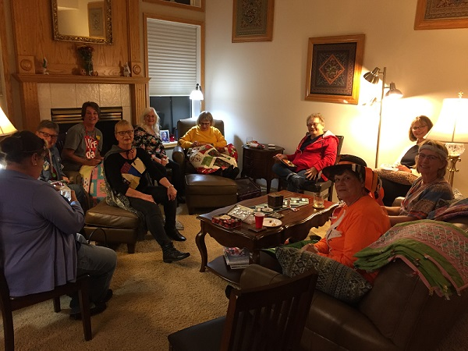

Guild members enjoying another Sip, Swap and Sew, a regular Special Event planned and hosted by Special Events chair Alice Sue Becker.

**“Pins to Pearls” Quilt Show**

Our 2019 Quilt Show was a wonderful success, thanks to all of you who entered your beautiful quilts. We heard many comments from both vendors and show attendees about the creativity and artistry of your quilts. The Best of Show award went to Sue Skoblik for Dance of the Dragon Flies. Five blue, five red, and five white ribbons won the Viewer’s Choice Awards. Ribbons were also awarded for the 2018 and 2019 President’s Challenge, Quilt Show Chair Choice, and Service Project representatives. See the last page of this newsletter for a list of all ribbon winners.

We couldn’t have done this without your help. Thanks to the many volunteers from SCHQ members, husbands, nursing students, and any other helpers. The committee members did a great job and worked together to make this a success.

We also want to thank the Service Project Committee for putting together a display of donations from our members. Visitors to the show were extremely impressed by the generosity of our group. Shown below is a photo of the service project display.

As soon as we have a final accounting of expenses, we will present a P&L statement to the membership.

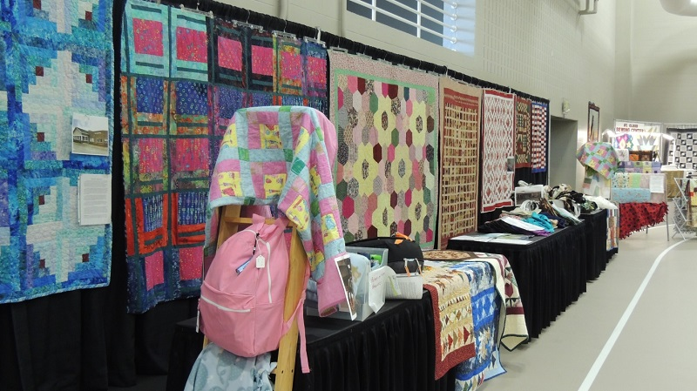

**Contact Barb Corson** **or** **Marjorie LaTour**

**QUILT SHOW 2019 Barb Corson & Marjorie La Tour**

Winners of the 2019 raffle quilt, Vijay and Usha

Fawn Wright sold the winning ticket.

**SUNSHINE Pat Gerchy**

If you know a guild member in need of a little sunshine, please call me (Pat’s phone number can be found on the mailing page attached with this newsletter) and if no answer leave a message or email me.

**Contact Pat Gerchy**

We will once again be sewing tote bags for Coborn’s Cancer Center. Please join us October 28 and 29, from 9:00 to 4:00 at the Eastside VFW, 104 Franklin Av. NE, St. Cloud. Bring a sewing machine or serger, and a bag lunch if you want. Coffee and water will be available. Come for the whole day or anytime for part of the day.

We continue to receive donations for all of our organizations. Thank you for your time and generosity!!

**Contact Elaine Randall**  **Sandi Abraham** **and Helen Manion**

**Service Projects Elaine Randall, Sandi Abraham, Helen Marion**

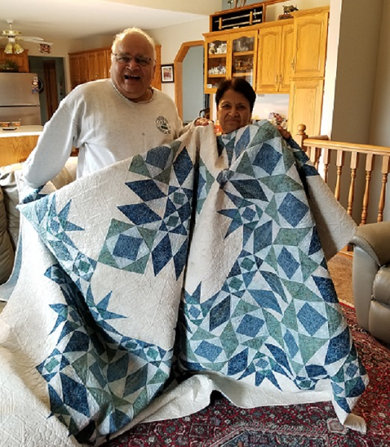

**SMALL GROUPS Karen Cyson**

**SERVICE PROJECTS- 2018 Elaine Randall, Sandi Abraham & Helen Manion**

Well it's that time of year again. SCHQ would love for you to renew your membership! Fill out your form and return it at the November or December meeting. Or simply drop into the mail.  The form is on our website and is attached with this newsletter.

As I move to Co-President with Chris Hoover I just want to thank you for being a member, and encourage you to bring a new friend to SCHQ to join, share, learn and socialize together in this wonderful world of quilting! Happy Sewing.

**Contact Julie Johnson:**

**Membership Julie Johnson**

We are getting closer to the reveal of our Mystery Quilt. November will be Clue #9, December clue #9, and in January I'll show you my finished project and hand out Clue #10 which is the assembly instructions.

In January we will also begin sign-ups for the 2020 Mystery Quilt. The February meeting will be the final opportunity to sign up and in March you will receive Clue #1. If you are a snowbird and would like to sign up, talk to me at the November or December meeting. Cost will be $5.

**Featherweight Group** - This group does fun projects throughout the year. To be part of this group, you must own and bring a Featherweight sewing machine. Julie Johnson is the facilitator. They meet the second Thursday of the month at 9:30 am at Messiah Lutheran Church in Sartell, MN. Contact Julie to be added to the email list for meeting notices.

**Undercolor Club –** This group meets the last Wednesday of the month at 5:30 pm at Dunn Bros. Coffee Shop in the Coborn's on Cooper the Ave. S. This group works with the "Color Play" book. Make a small project or bring fabrics to illustrate color combination. Contact Marlyn Anderson.

**Our next Triple S - Sip, Swap and Sew** – Another Sip, Swap and Sew is being planned for the winter months. Watch the newsletter for details.

**Contact Karen Cyson:**

We have 4 new members!  Welcome to Gail Negaard, Sue Kelly, Lois Christiansen, and Jena Eggersgluess. Current membership stands at 135 with one coming in the mail. Remind your quilting f

riends that they need to be a member to show quilts at our show. For the very low price of $25 you have access to a great social club, meetings, speakers and trunk shows. Go to the SCHQ website for membership forms.

**Contact Julie Johnson:** jjfarm65@gmail.com

**NEWSLETTER and WEBSITE Maggie Voigt**

Anyone is welcome to put an article in the newsletter. The deadline for receipt of articles to appear in the next newsletter isthe **12th** of the prior month. The guild also accepts ads. Contact me for advertising rates and requirements.

**Contact Maggie Voigt**

Remember to bring your 2019 membership card and wear your name tag at the meetings. Bring your show and tell items, birthday fabric/gift, $ for birthday fabric/gift tickets, and finished service projects.

**2019**

Nov 7 -- Board Meeting, 6:00; Guild Meeting, 7:00 **Angie Roberts** - Noble Quilt Shop, Elk River - *Incorporating Embroidery into Quilts*

Dec 5 -- Board Meeting, 6:00; Guild Meeting, 7:00 **Holiday Party** and **Donna Harjes’ miniquilts silent auction.**

**2020**

Jan 2 -- Board Meeting, 6:00; Guild Meeting, 7:00 **Colleen Anderson**, Millie P’s Quilt Shop, Trunk Show

**ST. CLOUD HERITAGE QUILT GUILD CALENDAR**

**SCHQ BOARD MINUTES Marie Zaczkowski**

**St. Cloud Heritage Quilters Board Meeting Minutes for October 3, 2019**

Members present: Karen Cyson (Small Groups), Dianne Kremer (Assistant Treasurer), Alice Sue Becker (Special Events), Marie Zaczkowski (Secretary), Teri Durbin (Programs), Elaine Randall (Service Projects), Maggie Voigt (Newsletter Editor), Julie Johnson (Membership). Chris Hoover attended the meeting as a guest.

The meeting was called to order at 6:00 PM by Elaine Randall, filling in for President Sandy Anderson.

Minutes of the September 5, 2019 board meeting were approved.

**BOARD REPORTS:**

**Special Events** (Alice Sue Becker): Another Sip, Swap and Sew event is scheduled for October 15th from 6 PM to 9 PM.

**Assistant Treasurer** (Dianne Kremer): Treasurer’s Report:

Treasurer’s Report was approved as presented.

**Special Projects** (Elaine Randall): Donated items were delivered to various agencies.

**Membership** (Julie Johnson): Membership forms for 2020 are available starting at tonight’s meeting. A 2020 membership form will be posted on the website and included with the next newsletter.

**Newsletter** (Maggie Voigt): The due date to submit articles for the November newsletter is October 12th.

**NEW BUSINESS**

A motion was made, seconded and approved to conduct a silent auction of the miniature quilts donated to the guild by former member Donna Harjes. The silent auction will be held at the December membership meeting/holiday party. Some of the quilts to be auctioned will be displayed at the November membership meeting. Funds raised will be used to bring in a national speaker for a future guild meeting.

The meeting was adjourned at 6:25 PM.

Submitted by Marie Zaczkowski, Secretary

**2019 Pins to Pearls Ribbon Awards**

|  |  |  |  |  |
| --- | --- | --- | --- | --- |
| **MEMBER NAME** | **QUILT #** | **AWARD** | **QUILT TITLE** | **QUILTER** |
| Sue Skoblik | 91 | Best in Show | Dance of the Dragonflies | Renee Sauve |
| Marilyn Bujalski | 167 | First Place | Gandalf - Lord of the Rings | Marilyn Bujalski |
| Mary Plas | 169 | First Place | Yikes! | Kathleen Crabtree |
| Lori Bauman | 177 | First Place | Dinner Plate Dahlia | Kathleen Crabtree |
| Sue Johnson | 61 | First Place | Quilting With Friends | Renee Sauve |
| Maggie Voigt | 17 | First Place | Dresden Scrap | Tom Kremer, The Back Porch Quilter |
| Lori Dornberg | 360 | Second Place | Let's Bake | Cindy Kleve |
| Lori Bauman | 176 | Second Place | Vintage Rose | Kathleen Crabtree |
| Maggie Voigt | 23 | Second Place | Mariners Compass | Tom Kremer, The Back Porch Quilter |
| Sue Skoblik | 355 | Second Place | Latimer Farms | Cindy Kleve |
| Diann Kraemer | 331 | Second Place | Shimmering Leaves | Tom Kremer, The Back Porch Quilter |
| Deb Danemann | 95 | Third Place | Rainbow Around | Renee Sauve |
| Debbie VanVleet | 241 | Third Place | Florida | Debbie VanVleet |
| Mary Plas | 168 | Third Place | Purple Rose | Kathleen Crabtree |
| Sarah Howard | 124 | Third Place | Snowy Barn | Sarah Howard |
| Chris Hoover | 160 | Third Place | Cullinan | Renee Sauve |
| Chris Fox | 490 | Coborn's Cancer Center | Northcott Autumn Splendor | Kathleen Crabtree |
| Sharon Jan-Carol | 438 | Anna Marie's Alliance | Trip Around the World | St. Joseph Quilt Group and us Sisters |
| Marlyn Anderson | 89 | 2019 Nurses Family Partnership | Water Garden | Marlyn Anderson |
| Sue Johnson | 61 | 2019 Recovery Plus-Adolescent | Quilting With Friends | Renee Sauve |
| Jan Pederson | 193 | 2019 Eagles Healing Nest | Holiday Flowers | Renee Sauve |
| Maggie Voigt | 23 | 2019 Pockets of Hope | Mariners Compass | Tom Kremer, The Back Porch Quilter |
| Sandy Anderson | 264 | 2018 President's Challenge | Orphans | Tom Kremer, The Back Porch Quilter |
| Margaret White | 462 | 2019 President's Challenge | Origami Pinwheels (in green and orange with purple) |  |
| Sarah Howard | 125 | 2019 Show Chair Choice | Fancy Flamingo Goes to the Quilt Show | Sarah Howard |
| Maggie Voigt | 16 | 2018 Recovery Plus | Stars Bursting | Tom Kremer, The Back Porch Quilter |
| Mary Billig | 290 | 2018 Pathways 4 Youth | Bali Sea Star | Tom Kremer, The Back Porch Quilter |
| Joyce Kron | 113 | 2018 Stearns Co. Tummy Time | Winnie the Pooh | Janet Peterson - Cornerstone Quilting |
| Benita Benschoter | 494 | 2018 Nurses Family Partnership | Cutting Corners | Darlene Felling |