# 

SEPTEMBER 2020

St. Cloud Heritage Quilters

[www.stcloudheritagequiltersofmn.com](http://www.stcloudheritagequiltersofmn.com)

**Next Meeting: No guild meeting in September**

Love of Christ Lutheran Church

1971 Pine Cone Road S.

St. Cloud, MN 56303

[Click here](https://www.google.com/maps/place/1971+Pine+Cone+Rd+S,+St+Cloud,+MN+56303/@45.5853668,-94.2232814,678m/data=!3m1!1e3!4m2!3m1!1s0x52b45e9135499525:0x62d24bbada5743a8?hl=en) for directions

# PRESIDENT’S COLUMN Chris Hoover

`

Hello everyone,

Most days it seems to me like time is at a standstill but it’s the middle of August already so where has the time gone? Are you spending these summer months doing “normal” things? My days include walking, reading, quilting, knitting, a little gardening – things I do every summer – but it also has included a lot of looking back on past summers. Last summer we traveled – a family vacation to the beaches of South Carolina and a wonderful cruise to Alaska. Every summer there were a few road trips to quilt shows and quilt shops with friends, almost weekly dinners on patios at our favorite restaurants, and some really great times with family and friends. I miss all of these things but most of all I miss seeing my quilting family and sharing my passion for all things related to our craft. If you didn’t get a chance to attend our SCHQ Quilt Rally (postponed from July to August), you missed a great show. As always, I was inspired by the beautiful creations fellow members shared. We are such a diverse group of talented quilters and it was so much fun to see the variety of projects on display: wool, brights, 30’s, patriotic, civil war, batik, panels, scrappy, flannel, hand dyed, and foundation pieced. There was everything from modern to traditional, simple to complex, queen size to miniature, hand and machine quilting – you name it. Our group can do it. Thank you so much to the members who displayed quilts and thanks to all of you who attended.

Thank you also to those of you who responded to our survey back in July. Your health and safety are important to us and we value your responses. At this time, we are canceling our September meeting. We hope to hold another outdoor event in October. Keep reading for more info.

Enjoy these last days of summer!

Chris

**Contact Chris Hoover**

**See the Quilt Guild calendar on page 7.**

**President Chris Hoover**

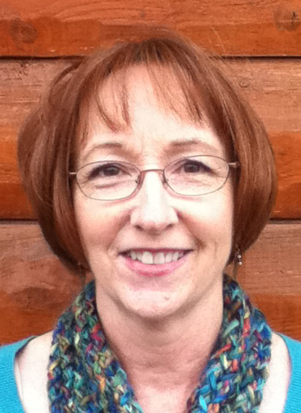



We greatly appreciate these very generous donations received this summer:

**Debra Ost and her husband** have made a donation to the guild in memory of Chris Fox in the amount of $50. This money will be used to offset costs of future classes for SCHQ members.

Service Projects has received a donation of 18 quilt tops - from youth to queen size, lots of fabric and some batting from **Pat Sweeney**.

**SERVICE PROJECTS Pat Gerchy and Sue Skoblik**

Service Projects has received a very generous donation of 18 quilt tops from **Pat Sweeney**. The tops range from youth to queen size, and Pat donated lots of fabric and some batting that can also be used for service projects. Now we just need to get the tops quilted. If you can help complete these quilts, please contact Pat Gerchy or Sue Skoblik.

**Contact Pat Gerchy or Sue Skoblik:**

**PROGRAMS Teri Olson**

**SCHQ Program Information**

What a year this has been.  Your program co-chairs had some great programs lined up and will be rescheduling our speakers in 2021 and 2022. There is one program that the we would like to have this year that we would prefer not to give up. The program is our QOV or Veterans Quilt Presentation scheduled for October. We are working on the logistics for a safe way to distribute quilts to our veterans by means of a “drive-in” style presentation with our veterans on the sidewalk in front of the church and members in the parking lot. With planning this program I am asking that if any members have quilts that they are willing to donate to our veterans for this presentation please contact Nancy Piltz, Chris Hoover or Teri Olson. We will arrange for veterans depending on the number of quilts we collect. Thank you for your generosity to this very worthwhile service project.

**Contact Nancy Piltz** **or Teri Durbin or Darlene Felling** **or Teri Olson**



Our website, <https://www.stcloudheritagequiltersofmn.com/>, now has a calendar feature. Our events, meetings, and get–togethers all in one spot. Check it out.

**MEMBERSHIP Julie Johnson**

**Monthly Tip – From Chris Hoover**

Do you put labels on your quilts? I am an impatient person – ready to move on to the next project as soon as that binding is done, so I very rarely take the time to put a label on my quilts. When I do, I either write something on a lower corner using a Pigma pen or I print a label using EQ Printables Inkjet Fabric Sheets. With the fabric sheets I can add pictures or images that I wouldn’t necessarily add if I was just writing on the backing fabric. But writing directly on the backing fabric is my preference – it seems more personal if it’s in my own handwriting. If I do make a label, I may include the following: name of the recipient if known (and the city where they live) and the occasion, a special message, the date – either the date it will be given or the date the quilt was completed, pieced by Chris Hoover, St Cloud MN and the name and city of the person who quilted it. Should the quilt ever “get lost”, hopefully this information will help it find its way home. Want to know more about quilt labels? Check out this great article from the AQS blog:

<http://www.aqsblog.com/a-comprehensive-guide-to-quilt-labels?trk_msg=058QDH532IB4VD2RH3AR10GU84&trk_contact=RGI2F5PUUVBP23GHMT8C25HQCC&trk_sid=HSETQDMKKUKO89HJKVOB403RBC&utm_source=listrak&utm_medium=email&utm_term=Learn+about+Quilt+Labels&utm_campaign=OnPoint&utm_content=OnPoint>

**President’s Challenge – It’s All About the Numbers**

Are you working on your President’s Challenge quilt? Because this is such a crazy year and because I just don’t think it will be feasible to have a meeting where we can all see these quilts and vote on our favorites, I’m going to ask that you send me a picture of your completed quilt by October 30 – a straight on shot in good light. I’m going to post these pictures (more info to come on where to find them) and I will ask you to cast your vote for your 2 favorite quilts. Prizes will be awarded – 2 prizes to members’ favorites and 1 prize for my favorite. You can send your picture at any time between now and October 30 to me.

**Contact Chris Hoover**

**2021 Board Members Chris Hoover**

It’s that time of year when we ask that you volunteer to help out on the SCHQ board for 2021. Those positions that are elected include President, President Elect, Secretary, Treasurer, Service Projects, Small Groups, Membership and Programs. Appointed positions are Newsletter, Sunshine, Website/Facebook and Meeting Coordinator. If you are interested in serving on the board in any of these positions or if you have questions regarding board positions, please contact Chris Hoover, Julie Johnson or Tom Kremer.

**Contact Chris Hoover**

**President’s Challenge 2020 Chris Hoover**

**SPECIAL EVENTS:  Together-Apart!**

Hi to everyone;

I have been missing all of you. It sure is hard to plan a special event when we can’t sew together, but we can sew together- apart! That is what I’m calling our first pandemic special event and I hope you will be inspired to join in.

Before I explain how this works, I’d like to tell you the story of how this idea came to be. For about 2 years, Mary Proell and I, both Tula Pink fans, would tell each other at Featherweight meetings, “We really should do a Tula challenge from our scraps!” But of course, we never got around to it. Then 3 things happened:  1.) We discovered we both owned Tula Pink’s “100 Modern Quilt Blocks” book. 2.) COVID 19 happened, and 3.) I challenged Mary to make a Tula Pink mask on Facebook and we both made the same dang mask!  Mary suggested we start our challenge by each making the same block and going on from there. Then we planned to share our blocks to create a quilt. She told me, “We can make a quilt together- apart!” and the name was born. At first we thought we’d donate the quilt, (to avoid fights over who got to take it home, I guess!). But then I thought, “Wait a minute- what if other friends wanted to do something similar using something THEY are passionate about?” We could make it a special event, have people show them at Show and Tell and then do a full display at the Quilt Show. They could be auctioned off by silent auction or even a regular auction, as a Guild fundraiser at the show, or donated. Or the makers can keep them, too. Just as long as there are no custody fights!

***So here’s the plan for the Together- Apart! Challenge***

- Find just 1 or 2 people (no more, just to keep things manageable, please) who share your passion for something in quilting. It could be ANYTHING - A certain designer, a particular color scheme, a technique you enjoy, like foundation piecing or English paper piecing, bags, wool work, batiks, or dying your own fabrics. Truly, ANYTHING you want it to be.

- Plan your work by communicating together, but then create the parts of your work apart from each other. Share frequently about what you’re doing with each other and as time goes on, we will all know if we can get together to join our pieces, or if one person in the pair or group of 3 will be responsible for sewing them together, depending on how the pandemic goes. Finish your projects anyway your heart desires!

- When the time comes that we can all see each other again, we could have a great show and tell of our quilts or a wonderful fundraiser at the quilt show but most importantly, we will have reached out to a friend or two to help make this time of isolation a bit less lonely.

I’m in, Mary Proell is in, and we’re starting our challenge with blocks #100 and #4 from our book. What will you do? I can’t wait to see what you create Together- Apart! If you have questions, please contact me. Thanks!

**Contact Alice Sue Becker**

**SPECIAL EVENTS Alice Sue Becker**

**2020 Mystery Quilt**

Clues will be available at any drive-by guild meetings. If you would prefer to have your clues mailed to you, send a SASE to Karen Cyson, 728 Washington Memorial Drive, Saint Cloud, MN 56301. Clues 1-8 are available now. After September 1 clues 9 & 10 will be available. In October

you will receive the finishing instructions.

**Contact Karen Cyson**

(Continued on Page 6)

**SMALL GROUPS Diann Kremer and Jan Stockinger**

**SCHQ Members Group Facebook Page**

There are many things we miss when we can’t get to a meeting: seeing our friends, hearing great speakers, winning birthday fabric and door prizes… One thing I miss the most is the Show and Tell portion of our meeting. I always say that we have wonderfully creative quilters in our group and I love seeing what you’ve been up to. So, in this time when we can’t get together and for those times when we can’t make it to a meeting, we decided to create a group Facebook page where members can post pictures of what they’ve been working on. To join, follow the directions below:

1. Log in to Facebook.

2. Search on St. Cloud Heritage Quilters and click on our regular Facebook page. This should be the first choice.

3. Look for the Groups tab. On my computer this was on the left. On my phone it was just under Publish and “No Rating Yet” but you need to scroll to the right. On my iPad it was to the right below “No Rating Yet”.

4. Click on the tab that says “Join” for the SCHQ Members Group. A request will be sent to the group administrators. Once we verify that you are a member in good standing (you’ve paid your dues), we will accept you as a member and you will be able to post pictures of what you are working on and comment on what others have posted.

Please note that this is a PRIVATE Facebook group. Only members will be allowed to join. We would love to see some virtual Show and Tell. Join us!



**SMALL GROUPS** (continued from page 5) **Diann Kremer and Jan Stockinger**

**Featherweight Group** –The Featherweight Small Group is for sewers who own a Featherweight Sewing Machine. Featherweight held a social distance gathering (outside) on Thursday, August 13th, 2020.  It was a nice gathering of friends and oh so very nice to get together again.  Watch your email for updates for the September gathering location and time.  Soon we will be sewing together again!

**Undercolor Club** –This group meets the last Wednesday of the month at 5:30 pm at Dunn Bros. Coffee Shop in the Coborn's on Cooper Ave. S. Members work with the "Color Play" book. Make a small project or bring fabrics to illustrate color combinations. Contact Marlyn Anderson.

**Handwork New Small Group** –If you like to do wool work, applique, handwork, or just need time to bind a quilt, join us. The new handwork group will meet at Julie Johnson's home.  All are welcome! Contact Julie Johnson

**Longarm/Midarm New Small Group** – The Longarm/Midarm Group is for quilters who do longarm or midarm machine quilting. The group meets the first Monday of the month at 6:30 p.m. at each other’s homes as space allows, or at Alice Sue Becker’s house. For more information and the location of the next meeting, please contact Alice Sue Becker or Kathy Gunderson, co-facilitators.

We (Diann Kremer & Jan Stockinger) are starting another small group called **Scrappy Stash Busters.** Let us know if you are interested. Keep on sewing up your Scrappy Stash Busters so you will have room to buy new fabric!

**Contact Diann Kremer or Jan Stockinger**

**NOTE: Check with the small group leader/coordinator to determine when the group will resume meeting or watch for information via email, on the guild website or in future newsletters.**

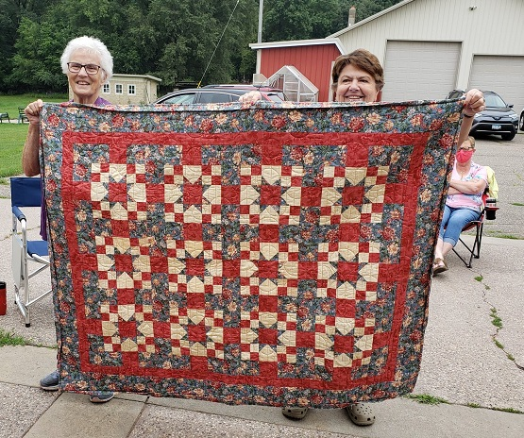

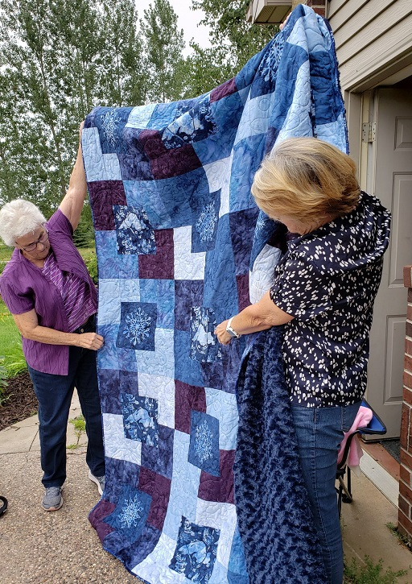

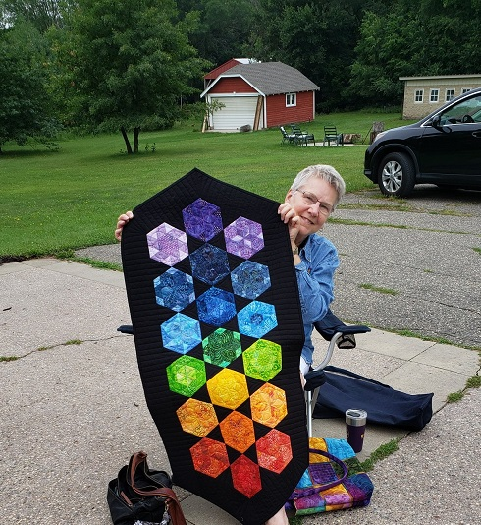

We have 4 new members!  Welcome to Gail Negaard, Sue Kelly, Lois Christiansen, and Jena Eggersgluess. Current membership stands at 135 with one coming in the mail. Remind your quilting f

riends that they need to be a member to show quilts at our show. For the very low price of $25 you have access to a great social club, meetings, speakers and trunk shows. Go to the SCHQ website for membership forms.

**Contact Julie Johnson:** jjfarm65@gmail.com

**SUNSHINE Mona Ritten**

If you know a guild member in need of a little sunshine, please call me (Mona’s phone number can be found on the mailing page attached with this newsletter) and if no answer leave a message or email me.

**Contact Mona Ritten**

**NEWSLETTER Marie Zaczkowski**

Anyone is welcome to put an article in the newsletter. The deadline for receipt of articles to appear in the October newsletter isthe **12th** of September. The guild also accepts ads. Contact me for advertising rates and requirements.

**Contact Marie Zaczkowski**

Remember to bring your 2020 membership card and wear your name tag at the meetings. Bring your show and tell items, birthday fabric/gift, $ for birthday fabric/gift tickets, and finished service projects.

**2020**

Sept. 3 -- No Guild Meeting this month

Oct. 1 -- 7:00 pm; **Quilts of Valor Presentation**

Nov. 5 -- TBD

Dec. 3 -- TBD

**ST. CLOUD HERITAGE QUILT GUILD CALENDAR**

**St. Cloud Heritage Quilters**

**Treasurer’s Report for August 2020**

SCHQ Checking Account Activity (1430)

**Beginning Balance in Quilt Checking as of 07/01/2020 $2,477.97**

**Income**

**.00**

**Total Income** $2,477.97

**Expenses**

Dept Date Check Payor Description

Bus 7-9-20 2696 WP Post Office box renewal 118.00

**Total Expenses** 118.00

**Ending Checkbook Balance as of 07/31/2020** $2,359.97

Savings Account Activity (5908)

**Beginning Balance as of 07/01/2020** $5,140.67

Transfer into Savings from Checking

Transfer out to checking

Transfer to Quilt show checking

Interest July .04

**Ending Savings Balance as of 07/31/2020** $5,140.71

Quilt Show Checking Account Activity

**Beginning Balance as of 07/01/2020** $1,543.50

Transfer into Checking from Savings

Transfer out to checking

Transfer to Quilt Show checking 00.00

**Ending Savings Balance as of 07/31/2020** $1,543.50

Heritage quilters CD Activity

**Beginning Balance as of 07/01/2020** $17,539.49

Transfer into Savings from CD/Interest

Transfer out to checking

Transfer to Quilt show checking 00.00

**Ending Savings Balance as of 07/31/2020** $17,539.49

Total of all 4 accounts **$26,583.67**

Contact Diane Kremer