## 

FEBRUARY 2020

St. Cloud Heritage Quilters

[www.stcloudheritagequiltersofmn.com](http://www.stcloudheritagequiltersofmn.com)

**Next Meeting: Feb. 6th, 2020**

**7:00 P.M**

Love of Christ Lutheran Church 1971 Pine Cone Road S.

St. Cloud, MN 56303

[Click here](https://www.google.com/maps/place/1971+Pine+Cone+Rd+S,+St+Cloud,+MN+56303/@45.5853668,-94.2232814,678m/data=!3m1!1e3!4m2!3m1!1s0x52b45e9135499525:0x62d24bbada5743a8?hl=en) for directions

# PRESIDENT’S COLUMN Chris Hoover

`

Happy quilting, everyone!

I have a sign in my home that says, “Today I choose joy.” It hangs in a prominent place so that I see it many times throughout the day. Some days it’s a challenge to “choose joy” but I know that if I do something quilt related – cut out a quilt, sew on a quilt, read a quilt magazine, or just think about quilting – I will be in a happy place. As little as 15 minutes can reset my thought process and lead me to a better state of mind. I hope that quilting brings the same good feelings to each of you because we have a lot of opportunities coming up for you to “choose joy” that is quilt related!

Thanks to all of you for your patience as the 2020 Board takes over. We had a few hiccups at the first meeting of the year and learned a lot. Life does happen and last minute speaker cancellations can occur (in this case, Millie P’s had a death in the family and a funeral the day of our meeting). We apologize for not having a “main attraction” for you and hope that you were able to find inspiration in our abbreviated meeting.

We made a lot of announcements and even shared a few “teasers” at the January meeting. Our next quilt show is over a year and a half away, but it takes time and planning and a lot of work to produce this event. I am very happy to say that Renee Sauve and I are ready to take on the challenge of chairing the 2021 SCHQ Quilt Show and we hope that you will be ready to be a part of this wonderful display of our hard work and talents. We have started working on the basics – a date, a location, a design for the raffle quilt and forming our committee. If you would like to help in the planning of the show or if you have ideas regarding the show, please contact Renee or me. More information will be coming at future meetings and in future newsletters!

I have one last bit of news to share with you. I have come up with my President’s Challenge for 2020. Keep reading for all the details – “It’s all about the NUMBERS!”

**Contact Chris Hoover**

**See the Quilt Guild calendar on page 8.**

**President Chris Hoover**



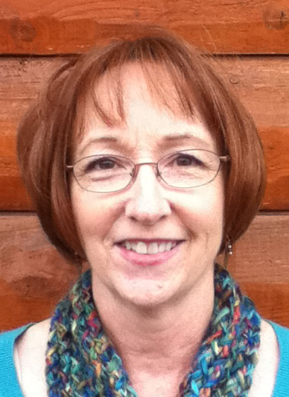

**It’s all about the NUMBERS!**

I’m a numbers person. By that I mean that I constantly seem to have numbers running through my head. I tend to count how many pieces I have yet to sew, how many pieces there are in each block, how much longer it’s going to take me (in minutes/hours) to finish the binding, etc. And that’s just numbers I think about when I’m quilting! So my quilt challenge to you had to be about the numbers – 2020.

The rules for this challenge are:

* The quilt must finish at 20” x 20”.
* The quilt must contain the two fabrics provided and you must add two other fabrics (to represent the “2”s in 2020). I will have bags available for pick up at the February, March and April meetings (no cost) that contain two fat 1/8th yards of fabric.
* The quilt must have at least two circles or “0”s somewhere on it (to represent the “0”s in 2020). These can be appliqued circles or circular shapes, circles in the additional two fabrics, or part of the quilting design.
* The quilt must contain 2 (and only 2) different quilt blocks. You may have as many or as few of these 2 blocks as you want, but you can’t have more than 2 different quilt blocks.

For example, your quilt may be:

* 1 – 20” block with another block embedded in the large block (i.e. a second block in the center square or corner square of the 20” block)
* 5” blocks that alternate in a 4 x 4 set
* 4” blocks that alternate in a 5 x 5 set
* blocks with plain squares or sashing
* 10” blocks that alternate in a 2 x 2 set or with plain squares set 2 x 2
* an art quilt with 2 blocks featured somewhere within the design
* random sized blocks in a random setting

Please consider adding a 2” sleeve to the back (top) of your quilt and entering it in the 2021 quilt show. There will be a category for these quilts.

The quilts will be displayed at our November meeting. Members will vote on their favorite. The November speaker and I will vote on our favorites. Prizes will be awarded!

I look forward to your creativity and hope that you will accept my challenge!

**Contact Chris Hoover**

**President’s Challenge 2020 Chris Hoover**

**MEMBERSHIP Julie Johnson**

**February Program** (Rescheduled from January)

Our speaker is Coleen Anderson from Millie P's Quilt Shop in Anoka. Coleen's interest in sewing began when she was very young. She was inspired by her grandmother who used previously worn garments and created new items. Coleen's favorite projects are creative functional objects "For the Home". Coleen will talk about what is new in the shop.

March 5 – Kristen Bender, Certified Judy Niemeyer instructor <http://www.quiltworx.com/instructors/kristen-bender/>

Workshop scheduled for March 6th and 7th

April 2– Marilyn Foreman, Twister Sisters <https://quiltmoments.com/>

May 7 – Bonnie Lundorff, Willow Wood Market <https://www.willowwoodmarketdesigns.com/>

**July meeting date has been rescheduled to July 16th! Our speaker will be Krista Moser** <https://www.kristamoser.com/>

**Contact Nancy Piltz**  **or Teri Durbin**  **or Darlene Felling** **or Teri Olson**

**Member Spotlight**

Inspiration abounds during the show and tell portion of our meetings so we know that all of the members of SCHQ are very talented quilters. And we know that each and every one of you probably has a few quilts that our members would love to see. Would you be willing to do a small trunk show at one of our meetings? Do you have 5-8 favorite quilts you could talk about for 15-20 minutes? We think this would be a great substitute when our speaker can’t make it at the last minute. Talk to Julie Johnson, Chris Hoover or any member of our Program Team (Nancy Piltz, Teri Olson, Darlene Felling or Teri Durbin) for more details. We are making a list and may be calling YOU!

Anyone is welcome to put an article in the newsletter. The deadline for receipt of articles to appear in the next newsletter isthe **12th** of the prior month. The guild also accepts ads. Contact me for advertising rates and requirements.

**Contact Marie Zaczkowski**

**NEWSLETTER Marie Zaczkowski**

**PROGRAMS Nancy Piltz**

The Service Projects for 2020 are as follows:

**Coborn’s Cancer Center – bags and hats**

**Pockets of Hope – quilts for any age child**

**Recovery Plus – twin size quilts for 12 – 18 year olds**

**Pathways 4 Youth – fleece blankets and warm quilts**

**Veteran’s Administration – quilts 70” x 90”**

Batting and backing will be furnished by St. Cloud Heritage Quilters for all donation quilts. At the November 2020 meeting, we will be accepting quilts for “Quilts of Honor” and they do not necessarily have to be red, white and blue. We will be setting dates for our next “sew ins” and the dates will be published in the next newsletter. Possible sites will be Eastside VFW, Gruber’s Quilt Shop or Love of Christ Church.

Thanks for all you do to support our service projects.

**Contact Pat Gerchy or Sue Skoblik:**

**Service Projects Pat Gerchy and Sue Skoblik**

Our website, <https://www.stcloudheritagequiltersofmn.com/>, now has a calendar feature. All our events, meetings, and get -togethers in one spot. Check it out.

Our winter Sip, Swap and Sew (Triple S) will be held from 6-9 p.m. on Tuesday, February 18th, at Alice Sue Becker’s house, 1213 Millstone Court, St. Cloud. The swap item will be a batik fat quarter.  Triple S is an evening of fun, food, wine and sewing open to all members of the guild and held 4 times a year. A main dish will be provided along with wine and nonalcoholic beverages; please bring along an appetizer, salad or dessert to share. Bring any handwork you’d like to do, too, and remember to bring your batik fat quarter to swap!

Please RSVP to Alice Sue or sign up at the February Guild meeting. Triple S is a fun way to get to meet other members, so we hope you can join us on February 18th.

**Contact Alice Sue Becker**

**SPECIAL EVENTS Alice Sue Becker**

**20 blocks for 2020 Sew-Along**

**Meeting Mentors**

We are looking for members who would be willing to greet guests and new members upon arrival and mentor them through their first SCHQ meeting (introduce them to other members, show them the birthday fabric area, explain our service projects and offer information on small groups, etc.). No sign up required and no commitment – assist at one meeting or all year, it’s up to you.

**If you would like to help, meet Julie Anderson or Fawn Wright at the membership table by 6:30 pm on meeting night.**

Greetings from Membership-

January was a very busy month, with 17 new memberships started and 24 renewals. Yes, you read this correctly - our guild added 17 new members in January! Welcome to the St. Cloud Heritage Quilters, and we look forward to a fun, creative year.

**Contact Julie Anderson**

**MEMBERSHIP Julie Anderson**

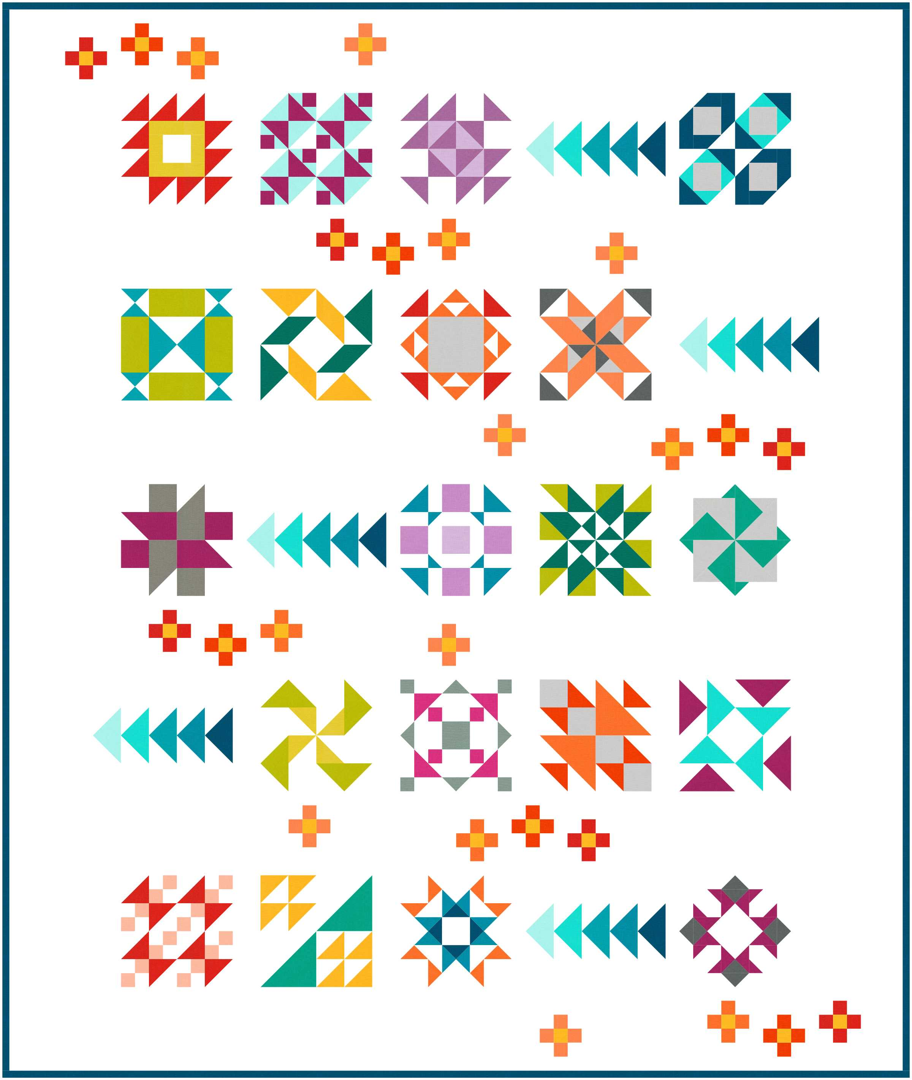

**20 Blocks in 2020**

This small group has become a very large group and I can’t wait to see your blocks and quilts! Patterns (labeled with your name) will be available for pick up each month on a table by the kitchen area. If patterns are not picked up, they will be held over to the following month/months. Would you like to see what colors and fabrics other members of the group are using? We will have a mini show and tell of the last month’s blocks by the table at 6:45. Please join us. Also, please remember that you must be a paid member of the guild to participate.

**Contact Chris Hoover**

**20 blocks for 2020 Sew-Along**

**SMALL GROUPS Diann Kremer and Jan Stockinger**

**2019 and 2020 Mystery Quilt**

Finishing instructions for the **2019 Mystery Quilt** were handed out at the January meeting. If you were not there to pick up your copy, they will be available in February and March. Any remaining will be mailed.

The February meeting is your final opportunity to sign up for the **2020 Mystery Quilt**. Cost is $4 for the year to cover the fee charged by the designer and copy costs. This quilt is a lap size with the possibility of adding borders to make it a generous twin. It uses 5 fabrics. The pattern is fun and a bit more complicated that the 2019 quilt, but certainly achievable even for a beginner. In February you will receive your shopping list (stash or store!), cutting instructions for the fabric, and Clue #1 which is very easy! There are 10 clues, so the final clue will be distributed in November.

**Featherweight Group –** The Featherweight Small Group is for sewers who own a Featherweight Sewing Machine. The group meets the second Thursday of the month at 9:30 am at Messiah Lutheran Church in Sartell, MN. Contact Julie Johnson to be added to the email list for meeting notices.

**Undercolor Club** –This group meets the last Wednesday of the month at 5:30 pm at Dunn Bros. Coffee Shop in the Coborn's on Cooper Ave. S. This group works with the "Color Play" book. Make a small project or bring fabrics to illustrate color combinations. Contact Marlyn Anderson.

**Handwork New Small Group -** If you like to do wool work, applique, handwork, or just need time to bind a quilt join us from 6-8pm at Julie Johnson's home. Please RSVP to her at so she can plan for space.

**Note:** The Handwork Group will meet from 6-8 pm on January 28th and February 25th at Julie Johnson’s house. Julie’s address is 140 75th St. NE, Rice, MN. Her phone number can be found on the mailing page attached with this newsletter.

**Longarm/Midarm New Small Group** – The Longarm/Midarm Group is for quilters who do longarm or midarm machine quilting. The group meets the first Monday of the month at 6:30 p.m. at each other’s homes as space allows, or at Alice Sue Becker’s house. For more information, please contact Alice Sue Becker or Kathy Gunderson, co- facilitators.

The Longarm/Midarm Group held its first meeting on January 6, 2020 at Alice Sue Becker’s house, with 14 members in attendance. The members introduced themselves and spoke about what they would like to gain from the new group. There was a general consensus that everyone wanted to learn from each other. Techniques and tips were shared (along with chocolate cake!) and the decision was made to provide guidelines to the Guild regarding what quilters need to do to prepare their quilt tops before sending them out to be quilted.

After a discussion on batting, the group decided to meet the first Monday of the month at 6:30. The next meeting will be held at Marilyn Bujalski’s house on February 3rd. All longarm and midarm quilters are invited to be a part of this group. If you are interested, please contact Alice Sue Becker.

(Continued on page 7)

We have 4 new members!  Welcome to Gail Negaard, Sue Kelly, Lois Christiansen, and Jena Eggersgluess. Current membership stands at 135 with one coming in the mail. Remind your quilting f

riends that they need to be a member to show quilts at our show. For the very low price of $25 you have access to a great social club, meetings, speakers and trunk shows. Go to the SCHQ website for membership forms.

**Contact Julie Johnson:** jjfarm65@gmail.com

**SUNSHINE Mona Ritten**

If you know a guild member in need of a little sunshine, please call me (Mona’s phone number can be found on the mailing page attached with this newsletter) and if no answer leave a message or email me.

**Contact Mona Ritten**

We (Diann Kremer & Jan Stockinger) would like to start another small group called **Scrappy Stash Busters.**

1. Pick a block pattern that you like.
2. You can only use fabric from your stash.
3. Only background fabric can be newly purchased.
4. Sewing can be done either at your home or if available sewing in Gruber's Classroom at a cost of $5, or if you eat in the café the $5 is waived.
5. When these quilts are finished, they can be given to the Guild to donate to our different service projects.
6. This is a win, win group! Our sewing rooms get room for a new stash supply and the recipients will be very happy with their new quilts!

Let us know if you are interested.

**Contact Diann Kremer or Jan Stockinger**

**SMALL GROUPS Diann Kremer and Jan Stockinger**

**ST. CLOUD HERITAGE QUILT GUILD CALENDAR**

Remember to bring your 2020 membership card and wear your name tag at the meetings. Bring your show and tell items, birthday fabric/gift, $ for birthday fabric/gift tickets, and finished service projects.

**2020**

Feb 6 -- Board Meeting, 5:15 pm; Guild Meeting, 7:00 pm; **Millie P’s Quilt Shop** <http://www.millieps.com/>

Mar 5 -- Board Meeting, 5:15 pm; Guild Meeting, 7:00 pm; **Kristen Bender**, Certified Judy Niemeyer instructor, <http://www.quiltworx.com/instructors/kristen-bender/>

Mar 6 & 7 -- Workshops with **Kristen Bender**

April 2 -- Board Meeting, 5:15 pm; Guild Meeting, 7:00 pm; **Marilyn Foreman**, Twister Sisters (Tool & Design) <https://quiltmoments.com/>

May 7 -- Board Meeting, 5:15 pm; Guild Meeting, 7:00 pm; **Bonnie Lundorff**, Willow Wood Market <https://www.willowwoodmarketdesigns.com/>

Watch for details about a workshop in May.

June 4 -- Board Meeting, 5:15 pm; Guild Meeting, 7:00 pm; TBD

July 16 -- **NOTE: This is not the 1st Thursday of July.**

Board Meeting, 5:15 pm; Guild Meeting, 7:00 pm; **Krista Moser**, <https://www.kristamoser.com/>

Aug 6 --

Sept. 3 --

Oct. 1 --

Nov. 5 --

Dec. 3 --

**SCHQ BOARD MINUTES Barb Corson**

**St Cloud Heritage Quilters Board Meeting Minutes for January 2, 2020**

Present: Chris Hoover (President), Julie Johnson (President Elect), Barb Corson (Secretary), Diane Kremer (Treasurer), Julie Anderson (Membership), Nancy Piltz (Programs), Sue Skoblik (Service Projects), Alice Sue Becker (Special Events), Jan Stockinger (Small Groups), Marie Zaczkowski (Newsletter), Tom Kremer (Meeting Coordinator), Sandy Anderson (Special Events), Maggie Voigt (Treasurer/Website)

The meeting was called to order at 5:20pm by Chris Hoover. The December 2019 minutes were approved with no corrections.

Treasurer Report (Diane Kremer): Dec. Income: Membership $930; Birthday Fabric $46.75; Quilt Show Profit $1048.06; Quilt Show Seed Money $3010; Silent Auction (Mini-quilts) $984; Mystery Quilt/Quilt Along $227. Total Income $6245.81 Dec. Expenses: Christmas Party $793.70; Small Groups $19.56; Sunshine $5.25; Newsletter $22. Total Expenses $840.51 EOM Bank Balances: Guild Checking $3699.83; Show Checking $188.50; Guild Savings $8135.03; Guild CD $17220.90 Total $29,244.26

The January Treasurer Report 2020 was approved unanimously.

A motion was approved to make the following change to the 2020 budget: Remove the $7240 miscellaneous income line. The budget will now reflect a deficit of $7240. This deficit will be covered by prior years’ income.

Membership (Julie Anderson): 92 members have renewed their membership so far and more are expected at the January meeting. An updated “Welcome Letter” will be provided to new members.

Programs (Nancy Piltz): The Board discussed methods for signing up for the special programs e.g. Kristen Bender’s upcoming class. Students who are Guild members will cover her teaching fee and the Guild will cover her board & lodging and travel expenses. Non-guild members who take the class will pay a higher fee. Guild members will receive information about this.

The “Schoolhouse” program planned for February was discussed. Teachers will receive a gift card from the Guild for participating.

Future Programs for coming years will be booked as soon as possible, especially with national teachers.

Service Projects (Sue Skoblik): The Board discussed options for venues to work on service projects as well as long/midarmers’ requirements for batting, size of backing etc. This will be further discussed at the meeting for long/midarmers.

Special Events (Alice Sue Becker): Alice Sue will host a Sip/Swap/Sew at her home on 2/18/20. Information will be provided to members about this.

Small Groups (Jan Stockinger): The committee will check with group leaders to determine which groups are continuing and any new groups to be formed. A meeting of Long/midarmers will also take place and information will be provided to members.

(Continued on page 10)

**SCHQ BOARD MINUTES (Continued) Barb Corson**

|  |  |  |  |  |  |  |  |  |
| --- | --- | --- | --- | --- | --- | --- | --- | --- |
| **SCHQ Budget Summary 2020** |  |  |  |  |  |  |  |  |
| **Revenue** | **Budget 2020** | **2020 Actual** |  | **Budget 2019** | **2019 Actual** |  | **Budget 2018** | **2018 Actual** |
| Membership | 4000.00 |  |  | 4500.00 | 4537.00 |  | 4500.00 | 2739.00 |
| Special Events | 200.00 |  |  |  | 181.25 |  |  |  |
| Birthday Money | 450.00 |  |  | 725.00 | 488.05 |  | 725.00 | 691.65 |
| Refreshments | 0.00 |  |  | 0.00 | 0.00 |  | 180.00 | 165.45 |
| Quilt Show Profit | 0.00 |  |  | 5000.00 | 1048.06 |  |  |  |
| Other (Donations, Interest, etc) | 0.00 |  |  | 500.00 | 1223.00 |  |  | 607.84 |
| Miscellaneous/ Over spending | 0.00 |  |  |  | 2692.00 |  | 100.00 | 612.50 |
| Seed Money (quilt show) | 0.00 |  |  | 5000.00 | 3010.00 |  |  |  |
| **Total Revenue** | **4650.00** | **0.00** |  | **10725.00** | **13179.36** |  | **5505.00** | **4816.44** |

(Continued on page 11)

(Continued from page 9)

A Google Calendar will be created to keep track of small groups and other events. Small groups will need to keep the Board updated about changes in time, etc. for their groups.

Old Business: A New Membership Brochure has been created and will be used.

Volunteer “Meeting Mentors” will assist new members to become familiar with the Guild.

Social Time starting at 6:30pm before each meeting will be held so that members can “catch up” before the formal meeting begins. Hopefully this will reduce the level of noise during presentations at meetings.

New Business: The Rental Contract with Love of Christ Church was unanimously approved. This will entail $1,000 per year for Guild meetings. Additional charges may be paid for special events held at the church.

The Board will look into purchasing a wireless microphone.

The 2021 Quilt Show will be held and planning will begin immediately.

An email will be sent to Guild members on days when weather forces a cancellation. The email should be sent out by 2pm on those days.

Thank-you notes were received from Anna Maries, Eagles Healing Nest and Recovery Plus for donations.

The meeting was adjourned at 6:25pm.

Respectfully Submitted,

Barb Corson, Co-Secretary

(Continued from page 10)

|  |  |  |  |  |  |  |  |  |
| --- | --- | --- | --- | --- | --- | --- | --- | --- |
| **SCHQ Budget Summary 2020 (Cont.)** |  |  |  |  |  |  |  |  |
| **Expenses/Board Positions** |  |  |  |  |  |  |  |  |
| Programs | 8000.00 |  |  | 3000.00 | 2500.14 |  | 3000.00 | 1227.89 |
| President | 100.00 |  |  | 50.00 | 8.16 |  | 50.00 | 52.52 |
| Secretary | 50.00 |  |  | 30.00 | 0.00 |  | 30.00 | 28.75 |
| Treasurer | 40.00 |  |  | 20.00 | 254.04 |  | 50.00 | 57.81 |
| Membership | 40.00 |  |  | 25.00 | 34.42 |  | 75.00 | 9.93 |
| Newsletter | 50.00 |  |  | 25.00 | 72.99 |  | 150.00 | 0.00 |
| Special Events | 200.00 |  |  | 100.00 | 185.00 |  | 100.00 | 500.00 |
| Small Groups | 160.00 |  |  | 100.00 | 101.76 |  | 60.00 | 627.45 |
| Historian | 0.00 |  |  | 0.00 | 0.00 |  | 30.00 | 0.00 |
| Website | 100.00 |  |  | 0.00 | 0.00 |  | 50.00 | 96.00 |
| Sunshine | 30.00 |  |  | 15.00 | 34.31 |  | 30.00 | 0.00 |
| Service Projects | 600.00 |  |  | 500.00 | 538.04 |  | 30.00 | 400.00 |
| **Overhead/Financial Obligations** | **2625.00** |  |  |  |  |  |  |  |
| Miscellaneous | 75.00 |  |  | 500.00 | 70.50 |  | 20.00 | 712.50 |
| Other |  |  |  |  | 410.00 |  |  | 62.57 |
| Other - Wire Fraud |  |  |  |  | 2725.00 |  |  |  |
|  |  |  |  |  |  |  |  |  |
| **Old Accounts (moved to OH) $2625** |  |  |  |  |  |  |  |  |
| Christmas Party/refreshments | 600.00 | 0.00 |  | 450.00 | 595.20 |  | 150.00 | 546.38 |
| Guild Insurance (in OH in 2020) | 400.00 | 0.00 |  | 400.00 | 373.00 |  | 370.00 | 366.00 |
| IRS Taxes (in OH in 2020) | 300.00 | 0.00 |  | 300.00 | 290.00 |  | 300.00 | 2075.00 |
| PO Box Rental (in OH in 2020) | 110.00 | 0.00 |  | 100.00 | 106.00 |  | 90.00 | 96.00 |
| Website Hosting (Weebly) (in Website) | 0.00 | 0.00 |  | 150.00 | 96.00 |  | 120.00 | 33.90 |
| Facility Rental (Donation) | 1000.00 | 0.00 |  | 1000.00 | 1000.00 |  | 1000.00 | 1000.00 |
| Capital Equipment/durable goods | 50.00 | 0.00 |  | 0.00 | 239.97 |  | 50.00 | 0.00 |
| Debit/Credit Card Payments | 0.00 | 0.00 |  | 0.00 | 0.00 |  | 0.00 | 0.00 |
| Marketing | 0.00 | 0.00 |  | 50.00 | 0.00 |  | 125.00 | 0.00 |
| Prizes | 175.00 | 0.00 |  | 120.00 | 198.50 |  | 0.00 | 294.74 |
| Seed Money (quilt show) | 0.00 | 0.00 |  | 5000.00 | 3010.00 |  | 0.00 | 1600.00 |
| Librarian (No budget after 2019) |  |  |  | 0.00 |  |  | 100.00 | 75.47 |
| **Total Expenses** | **12070.00** | **0.00** |  | **11935.00** | **12843.03** |  | **5980.00** | **9862.91** |
|  |  |  |  |  |  |  |  |  |
| **Cash Short/Extra** | **-7420.00** | **0.00** |  | **-1210.00** | **336.33** |  | **-475.00** | **-5046.47** |
| NOTES: Budget 2020: Note that $7420 deficit will be covered by using the past years earnings | | | | | |  |  |  |
| **Account Balances Year End 12.31** |  | **2020** |  |  | **2019** |  |  | **2018** |
| **Checking** |  | **$0.00** |  |  | **$3,699.83** |  |  | $3,907.04 |
| **Savings** |  | **$0.00** |  |  | **$8,135.03** |  |  | $4,583.72 |
| **Quilt Show Checking** |  | **$0.00** |  |  | **$188.50** |  |  | $198.50 |
| **CD Deposit (new 1.29.2019)** |  | **$0.00** |  |  | **$17,220.90** |  |  | $20,000.00 |
| **Total of all accounts** |  | **$0.00** |  |  | **$29,244.26** |  |  | **$28,689.26** |

We would love to have you visit the 48th Annual Kalona Quilt Show and Sale in Kalona, IA.

Kalona is an Amish/Mennonite community known for quilting. The show is held at the Kalona YMCA at 511 C. Ave, Downtown, Kalona, IA.  Over 250 New and Vintage “Hand Quilted” quilts will be on display and for sale. Just one block east is the Kalona Quilt and Textile Museum featuring 2 quilt galleries. The Kalona Chamber offers 90 minute tours twice a day in the Amish country.

There are 2 wonderful fabric stores, coffee shop, chocolate store, gift shops, antiques and so much more. The local Methodist Church does a wonder turkey dinner during the show. Other restaurants available as well. Nice family owned motel as well!

Great ‘QUILTING GETAWAY”. And of course the Woodin Wheel Quilt and Gift shop that sponsors the show will be open as well!! Please join us for this fun event!

Kalona Quilt Show and Sale 2020

511 C Ave, Kalona, IA. 52247

Located in the Kalona YMCA.  East Entrance

Thursday, April 23,  5 pm – 8pm  (EVE. ONLY)

Friday, April 24,  9 am – 7 pm

Saturday, April 25, 9 am – 5 pm

Admission Charged $6.00  good for all 3 days

Sponsored by the Woodin Wheel  515 B. Ave. Kalona , Ia. 319-656-2240

Over 250 New and Vintage Hand Quilted Quilts on display and for sale.  Many are Amish/Mennonite made.

If you wish to have more information, call the above number or email. The Chamber of Commerce will send out Kalona information.

Hope to see you there!

Katie Karnes and Brenda Herington

Woodin Wheel

**UPCOMING QUILT SHOWS**